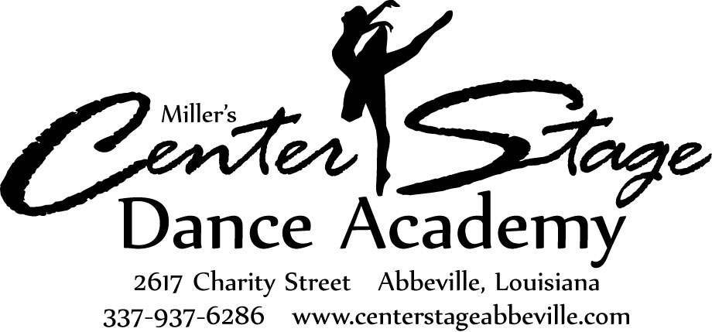
Classes begin after Labor Day and conclude
at the end of May with our annual Revue.

Classes consist of 45 minutes to 1 hour
classes per week depending upon the
combination of classes taken.

2023-2024 Registration Form

Early Bird Registration: May 1-31, $50 per family Registration: June 1-Aug. 31, $60 per family
(family=siblings living in the same household; NOT cousins)

Payment must accompany this form (Registration is non-refundable.)
Mail completed form and payment to: Center Stage Dance Academy, 311 N Geoffroy St., Erath, LA 70533.

Student’s name: Date of Birth: Grade:

Parent/Guardian’s name (person responsible for payment): ________________________________________

Address: City/Zip:

Contact numbers, home/cell: work/other:

E-mail address: ______________________________________________

I am registering my child in the following classes: (for detailed class definitions, please see website)
□ Tap and ballet combo class (45 mins to 1 hr. per week for 3-6 yrs. old)
□ Tap and jazz combo class (1 hr. & 15 mins. per week for 7-13 yrs. old)
□ Tap/Jazz/Lyrical combo class (Juniors and Advance class, 1 hr. & 15 mins. per week for 11 yrs. old and older)
□ Tap only (30 mins. per week for 7-18 yrs. old)
□ Jazz only (45 mins. per week for 7-13 yrs. old)
□ Jazz/Lyrical only (Juniors and Advance class, 45 mins. class per week for 11 yrs. old and older; they have to do both)
□ Ballet or Advance Ballet (45 mins. per week for 7 yrs. old and older)
□ Pointe (45 mins. per week for 11 yrs. old and older with 3 yrs. of prior ballet experience)
□ Hip-Hop Minis (30 mins. per week for 5-6 yrs. old)
□ Hip-Hop I, or Hip Hop II (30 mins. per week for 7-13 yrs. old)
□ Hip-Hop III or Hip Hop Advance (45 mins. per week for 11 yrs. old and older. Placement is at teacher’s discretion)
□ Tumbling Beginner (45 mins. per week for 5-10 yrs. old. For students who have not had prior tumbling classes)
□ Tumbling Intermediate or Advanced (1 hr. per week for 6-18 yrs. old. Placement is at teacher’s discretion)
□ Special Needs Class (30 mins. per week for children with special needs and/or learning disabilities)

For awards and our records, please indicate the number of years your child has completed:

Combo - Tap/Ballet or Tap/Jazz:___________ Ballet only: ___________ Hip Hop: ___________

Gymnastics/tumbling: ___________ Pointe: ___________

To help us teach your child, please let us know important things about them such as if they take medication on a regular basis (for ADHA or another diagnosis), scared of thunder, very shy, etc. (This will be kept confidential):

